Introduction
Credit risk assessment is one of the most critical functions in retail banking. When a customer applies for a loan, the bank must evaluate the likelihood of repayment — approving too freely leads to financial losses, while being overly restrictive means losing viable customers. This project analyses a real-world credit dataset to identify the borrower and loan characteristics that most strongly predict default, with the goal of providing data-driven insights that can support smarter, more consistent lending decisions.

Data
The dataset used in this analysis is the Credit Risk Dataset sourced from Kaggle (https://www.kaggle.com/datasets/laotse/credit-risk-dataset). It contains 32,581 records and 12 features capturing borrower demographics, financial profile, and loan characteristics. The target variable, loan_status, indicates whether a borrower defaulted (1) or not (0). Key features include annual income, employment length, loan amount, interest rate, loan intent, loan grade, and credit history length — variables that collectively reflect a borrower's capacity and willingness to repay.

Data Cleaning
An initial inspection revealed missing values in two columns: person_emp_length (895 missing) and loan_int_rate (3,116 missing).
For person_emp_length, missing values were filled with 0, reflecting borrowers with no recorded employment history — a defensible assumption consistent with unemployment or recent entry into the workforce.
For loan_int_rate, rows were removed after confirming that the default rate within the missing subset (20.67%) closely mirrored the overall dataset default rate (21.82%), indicating the data was missing at random. Removal therefore introduced minimal bias. Following cleaning, the dataset contains 29,465 records with a default rate of 21.94%.
Outlier Treatment
Outliers are data points that fall outside the range of realistic or expected values. Left unaddressed, extreme values can distort model training and lead to misleading predictions.
An inspection revealed extreme values in three columns. person_age contained a maximum value of 144 years, person_emp_length reached 123 years, and person_income had a maximum of $2,039,784 — far beyond what would be expected for a retail loan applicant. These were identified as likely data entry errors rather than genuine records.
Realistic upper thresholds were applied: 90 years for age, 60 years for employment length, and $150,000 for annual income. The income threshold was validated using the IQR method, which suggested a cutoff of approximately $140,000 — consistent with the chosen value. After applying the correct filters, 1,038 rows (3.52% of the dataset) were removed. The default rate shifted marginally from 21.94% to 22.37%, confirming that outlier removal introduced no material bias. The final cleaned dataset contains 28,427 records.
Key Finding: Prior Default History as a Risk Indicator
A cross-tabulation of historical default status against current loan outcomes reveals a striking pattern. Borrowers with no prior default on record defaulted at a rate of 18.9%, while those with a prior default on file defaulted at 38.7% — more than double the rate. This finding strongly supports the inclusion of credit history as a core feature in any risk assessment model, and suggests that lending institutions should apply heightened scrutiny to applicants with a recorded history of default, regardless of their current financial profile.

Exploratory Data Analysis
To understand the patterns driving loan default, five key relationships were examined across the cleaned dataset.
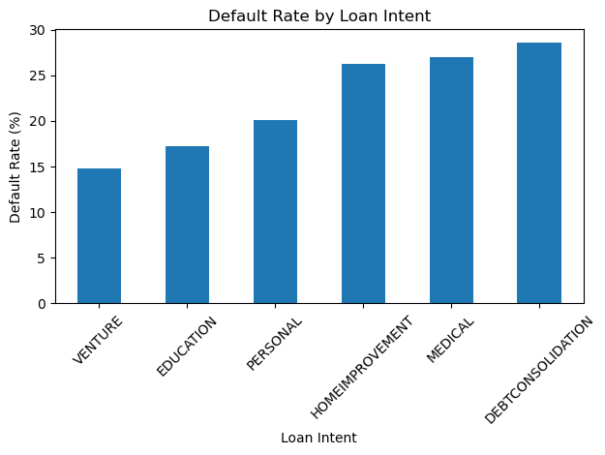
Default Rate by Loan Intent Debt consolidation loans carry the highest default rate at 29%, while venture loans are the lowest at 15%. This pattern is intuitive — borrowers consolidating debt are likely already financially stretched, whereas those taking venture loans may have more deliberate financial planning behind their decision. Banks should apply stricter assessment criteria to debt consolidation applicants as a baseline practice.
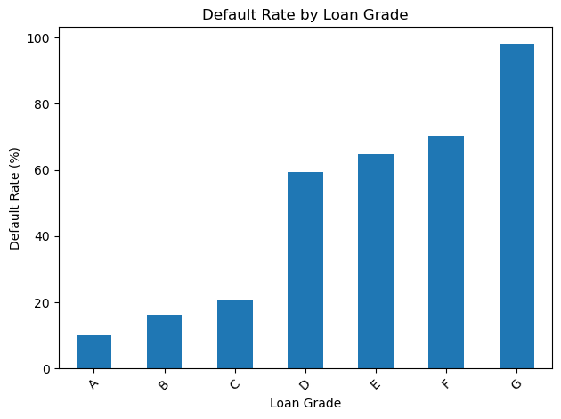 Default Rate by Loan Grade Default rates increase sharply with declining loan grade. Grade A borrowers default at approximately 10%, while Grade G borrowers default at nearly 100%. A clear risk threshold emerges at Grade D, where default rates exceed 60%. Banks should apply significantly stricter approval criteria for Grade D and below, and consider these applications high risk by default.
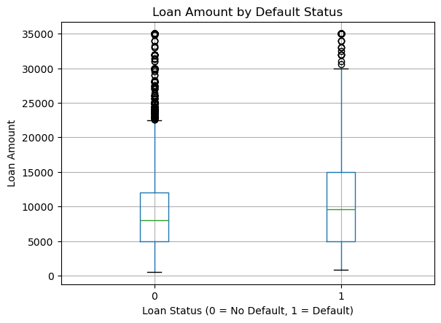

Loan Amount by Default Status The distribution of loan amounts is nearly identical between defaulters and non-defaulters, with medians around $8,000–$10,000 for both groups. This suggests that loan amount alone is not a reliable predictor of default risk and should not be used in isolation when making lending decisions.
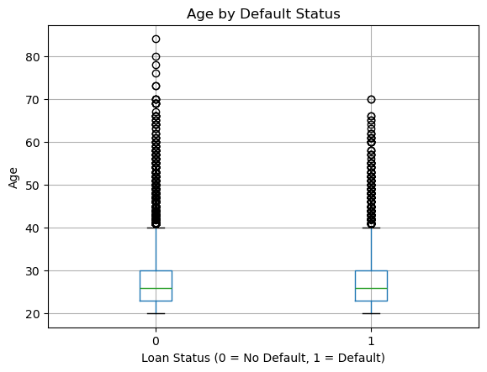

Age by Default Status The age distribution shows minimal difference between defaulters and non-defaulters, with both groups centred around a median of approximately 25–26 years. Age does not appear to be a strong standalone predictor in this dataset, though it may contribute value in combination with other features during modelling.
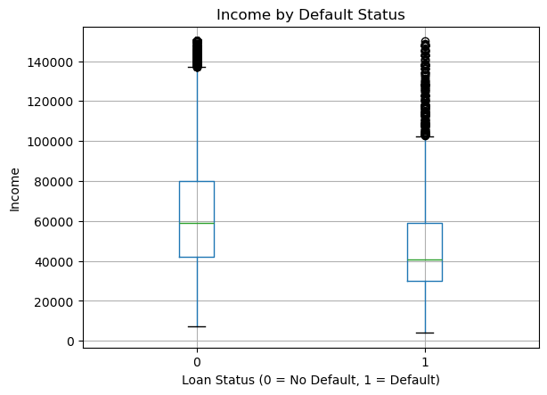
Income by Default Status A clear income gap exists between the two groups. Non-defaulters have a median income of approximately $60,000, while defaulters sit closer to $40,000. Lower income is associated with higher default risk, suggesting that income should be weighted heavily alongside other factors — particularly loan grade and prior default history — when assessing borderline applications.

Feature Selection
Following exploratory data analysis and correlation analysis, eight features were selected for model training. The target variable loan_status (0 = no default, 1 = default) was excluded from features, and loan_int_rate was deliberately excluded due to data leakage concerns — as interest rate is assigned by the bank after assessing borrower risk, it represents a consequence of the lending decision rather than an independent predictor.
The selected features and their justifications are as follows:
loan_percent_income — the strongest predictor (r = 0.38), capturing the ratio of loan amount to annual income. This reflects financial stress more precisely than raw income alone.
loan_grade — the bank's internal risk classification of the borrower, strongly associated with default rates ranging from 10% at Grade A to nearly 100% at Grade G.
person_income — higher income is negatively correlated with default (r = -0.25), reflecting greater capacity to meet repayment obligations.
cb_person_default_on_file — borrowers with a prior default on record defaulted at 38.7% compared to 18.9% for those without, making this one of the most practically significant predictors.
home_ownership — renters showed higher default rates than mortgage holders or owners, signalling differences in financial stability across housing categories.
loan_intent — loan purpose influences default risk, with debt consolidation borrowers defaulting at 29% compared to 15% for venture loans.
person_emp_length — employment length serves as a proxy for income stability and financial resilience.
person_age — while not a strong standalone predictor, age may contribute value in combination with other features during modelling.
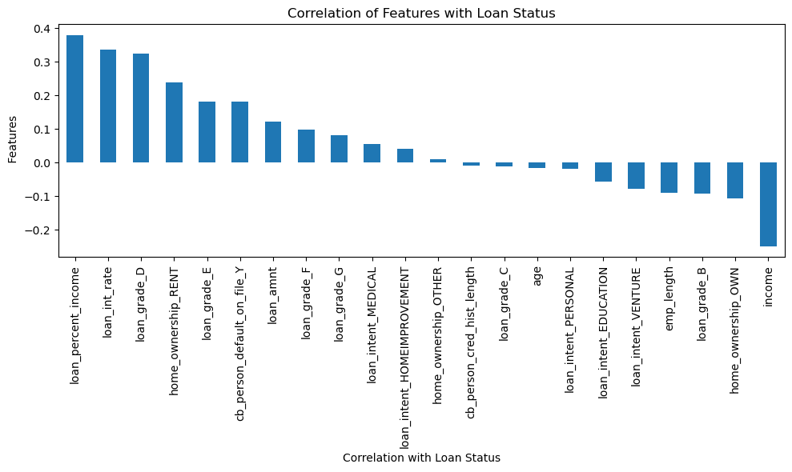

Model Development
Following feature selection, the dataset was split into training and test sets using an 80/20 ratio, resulting in 22,741 training records and 5,686 test records. Stratified splitting was applied to ensure the default rate of 22.37% was preserved consistently across both sets. Three supervised classification models were trained and evaluated: Logistic Regression, Random Forest, and XGBoost.

Model Results
Model | Recall(Default) | Precision(default) | F1(Default) | ROC AUC
Logistic Regression | 0.55 | 0.77 | 0.64 | 0.866
Random Forest | 0.73 | 0.96 | 0.83 | 0.934
XGBoost | 0.74 | 0.95 | 0.83 | 0.950

Given that the cost of missing a defaulter exceeds the cost of incorrectly flagging a safe borrower, recall for the default class was prioritised as the primary evaluation metric. XGBoost achieved the highest recall (0.74) and ROC AUC (0.950), meaning it correctly identifies 74% of actual defaulters and can distinguish between defaulters and non-defaulters with 95% reliability across all decision thresholds. XGBoost was therefore selected as the final model.
Notably, removing loan_int_rate due to data leakage concerns had negligible impact on model performance — AUC remained at 0.950 — confirming that the underlying borrower characteristics provide sufficient predictive signal without relying on a derived variable.
Model Explain ability – SHAP Analysis
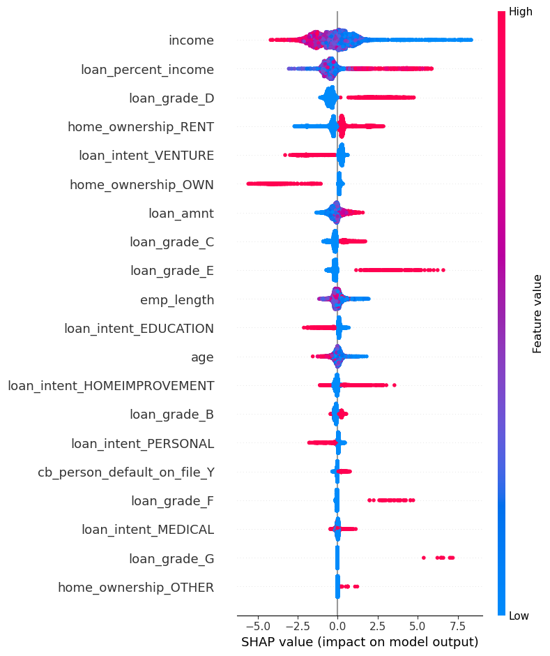
To ensure the model's decisions are interpretable and actionable for lending teams, SHAP (Shapley Additive Explanations) analysis was applied to the XGBoost model. SHAP assigns each feature a contribution value for every individual prediction, making it possible to understand not just which features matter globally, but how and in which direction they influence each decision.
The five most influential features identified are:
Income — the strongest predictor overall. Low income borrowers (blue) show SHAP values pushing toward default, with values reaching +7.5. High income borrowers (red) are pushed toward non-default. This confirms that income is the primary signal of a borrower's capacity to repay.
Loan percent income — the second strongest predictor. High values (red) push strongly toward default, indicating that when a loan represents a large proportion of a borrower's annual income, financial stress increases significantly and default risk rises accordingly.
Loan grade D — borrowers classified at Grade D show a clear positive push toward default. This is consistent with the EDA finding that default rates exceed 60% at Grade D, representing a critical risk threshold for lending decisions.
Home ownership — RENT — renters show a positive push toward default compared to other ownership categories, suggesting that renting is associated with lower financial stability and higher repayment risk.
Home ownership — OWN — homeowners show the opposite pattern, with high values pushing strongly toward non-default. Owning property is associated with demonstrated financial stability and significantly lower default risk.
Together these findings suggest that a borrower's financial capacity — captured through income, loan-to-income ratio, and housing stability — is the dominant driver of default risk, with the bank's own risk classification (loan grade) serving as a strong confirmatory signal.

Conclusion
This project set out to identify the borrower and loan characteristics that most strongly predict default risk in retail lending. Through systematic data cleaning, feature selection, and the evaluation of three machine learning models, XGBoost emerged as the strongest performer with a ROC AUC of 0.950 and a default recall of 74% — meaning it correctly identifies nearly three quarters of actual defaulters. SHAP analysis confirmed that a borrower's financial capacity, captured through income, loan-to-income ratio, and housing stability, are the dominant drivers of default risk. These findings provide a data-driven foundation for more consistent and transparent lending decisions.

Business Recommendations
Based on the analysis, the following recommendations are made for lending institutions:
Prioritise income and loan-to-income ratio in application assessment. Income emerged as the single strongest predictor of default. Borrowers whose loan amount represents a high proportion of their annual income are significantly more likely to default. Lenders should establish clear thresholds for loan_percent_income and flag applications that exceed them for enhanced review.
Apply heightened scrutiny to Grade D and below applicants. The analysis confirmed that default rates exceed 60% at Grade D and approach 100% at Grade G. Applications in these categories should require additional supporting evidence of repayment capacity before approval is granted.
Weight home ownership status in risk scoring. Homeowners demonstrated significantly lower default risk compared to renters. While home ownership alone should not determine approval, it should be incorporated as a positive risk factor in scoring models.
Flag applicants with prior default history. Borrowers with a recorded prior default defaulted at 38.7% — more than double the rate of those without. This variable should be treated as a high-priority risk signal regardless of other positive indicators in the application.

